Chapter 3, Solution 87

For the circuit in Fig. 3.123, find the gain v_{o}/v_{s}.

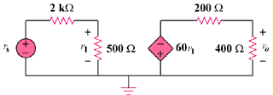

Figure 3.123
For Prob. 3.87.

Solution

v₁ = 500(v_{s})/(500 + 2000) = v_{s}/5

v₀ = -400(60v₁)/(400 + 2000) = -40v₁ = -40(v_{s}/5) = -8v_{s},

Therefore, v₀/v_{s} = –8

